**Management Plan: Sprint #4**

**Gnatt Chart:**

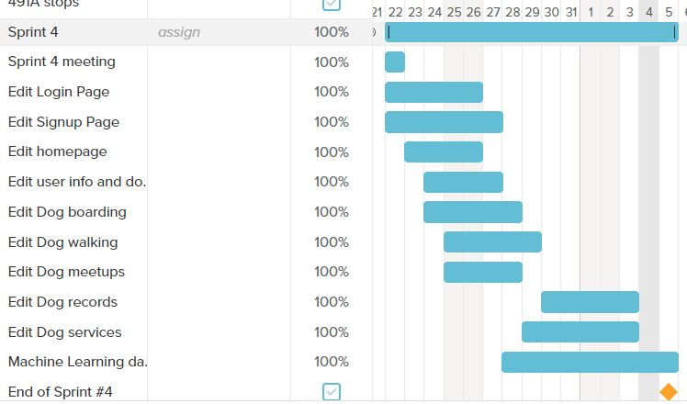The primary goal of this sprint was to continue coding the features pages adding visual appeal and fix some bugs that we found in our code from our previous sprint. We also planned to continue our research about the machine learning model that we will be using.

**Code Development velocity calculation:**

In this sprint, we had planned to finish 67 points worth tasks and we were able to finish it on time.

**Sprint Retrospective:**We finished all the tasks that were planned for this sprint on time. 67 points were planned in this sprint. We were able to complete those 67 points on time. Commitment per person every week= 5hrs.Team commitment per sprint= 5hrs *6 people * 2 weeks = 60hrs. The burndown chart was not exactly linear because some progress was based on user feedback, which took time to collect and review. There was also a learning curve. However, we were able to finish all the tasks. The right amount of tasks were assigned in this sprint which could be completed in the given timeframe.There was communication between members for finishing tasks. We need to provide more time for testing the code we wrote. We also need to prioritize the basic features to provide complete functionality to the web application. We decided the user stories with the highest priority based on the user survey that we conducted. There are approximately seven story points in progress currently.